Project Development Phase
Performance Test

Date | 27/10/2026
Team ID | Swasti Jain
Project Name | Electric Vehicle Market Performance & Insights
Maximum Marks

Project Performance Testing:

S.No. | Parameter | Screenshot / Values
 | Data Rendered | 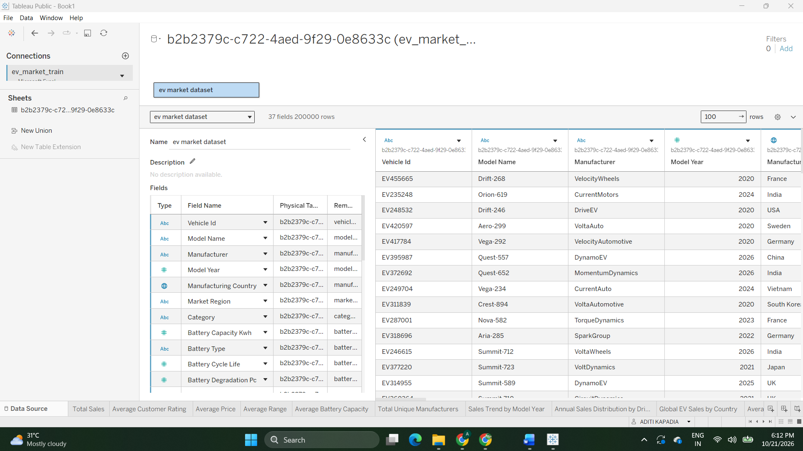
 | Data Preprocessing | Checked the dataset for null values and converted fractional values into decimal format to ensure consistency and accuracy during analysis and visualization.
4. | Calculation fields Used | Created calculated fields and aggregations in Tableau to derive key performance metrics such as EVs by Category, Sales by Manufacture, Range by Battery Type, Rating by Category, EV Records by Manufacturing Country, Price VS Range, Average CO2 Saving by Category, Battery Capacity by type and Annual Sales by Model Year. These calculations were used to compare EV categories, manufacturers, regions, and other market segments and support the dashboard visualizations.
5. | Dashboard design | No of Visualizations / Graphs – 12  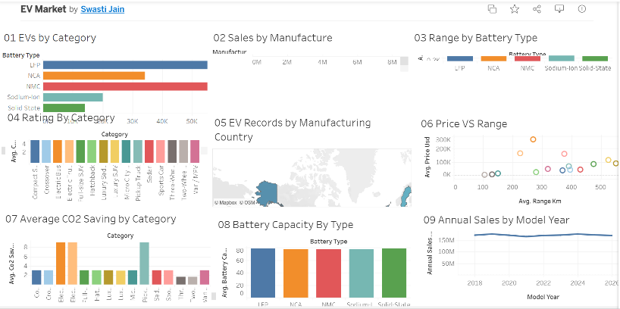
6 | Story Design | No of Visualizations / Graphs -12  

